Lab 07: Test & Deploy
In this lab you will complete solution configuration by adding security roles for the users. Then you will verify, test, and deploy your solution in the production environment.
- What you will learn
- How to deploy a solution to another environment
- High-level lab steps
- Exercise 1 – Create security roles for users
  - Company 311 User – read all on Building, user own on problem reports
  - Company 311 Admin – All for Buildings, Departments, Problem reports
  - Associate Company 311 Admin role with model-driven app
- Exercise 2 – Run solution checker
- Exercise 3 – Use Test Studio to create Test case for submitting problem (ok to not include image)
- Exercise 4 – Export and import solution
- Prerequisites
- Must have completed Lab 02: Data model and model-driven app
- Detailed steps
- Exercise 1: Create security roles
In this exercise, you create security roles for users.

Task 1: Create security roles
- Navigate to the Power Apps maker portal and make sure you are in the correct environment.
- Select Solutions and click to open the Company 311 solution.
- Click + New and select Other | Security Role.
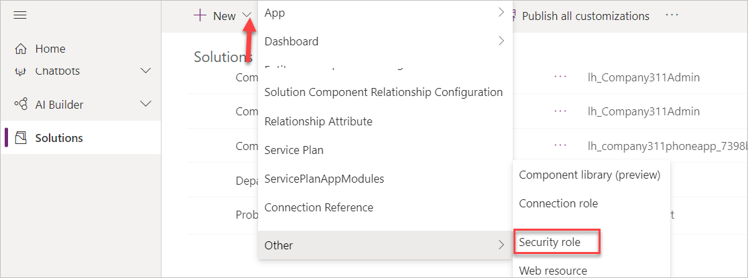
- Enter Company 311 User for Role Name and select the Custom Tables tab.
- Set the read privilege of the Building Table to Organization.
- Set the read privilege of the Problem Report Table to User.
- The read privileges for the Building and Problem Report Tables should now look like the image below. Click Save Create New.
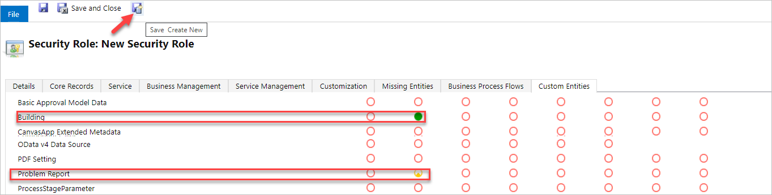
- Enter Company 311 Admin for Role Name and select the Custom Tables tab
- Set all privilege of the Building, Department, and Problem Reports Tables to Organization.
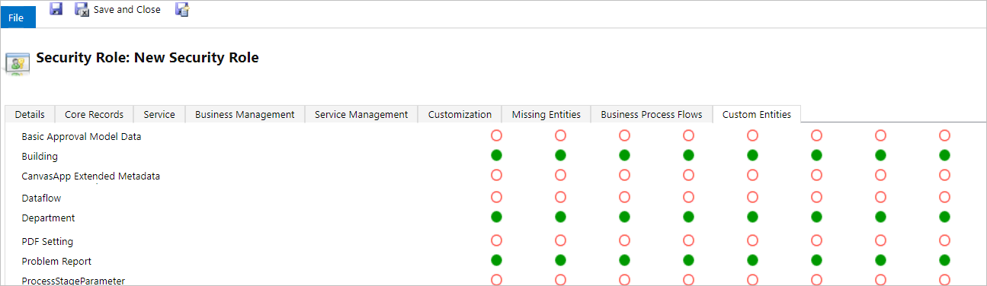
- Select the Customizations tab.
- Associate Model-driven app with the Company 311 Admin role.
- Click Save and Close.
- Click Done on the popup.
- Select Solutions.
- Click Publish all customizations and wait for the publishing to complete.
- Exercise 2: Solution checker
In this exercise, you will run the solution checker on the Company 311 solution.

Task 1: Run solutions checker
- Make sure you are still on the Power Apps maker portal site and you are in the correct environment.
- Select Solutions, click Solution checker, and select Run.
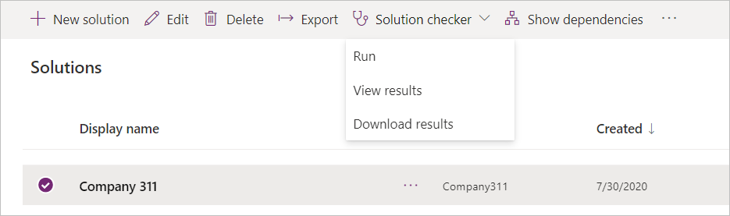
- The solution checker should start checking your solution, wait for the it to complete. The solution check column value will change to Results with a timestamp.
- Select the solution again, click Solution checker, and select View results.
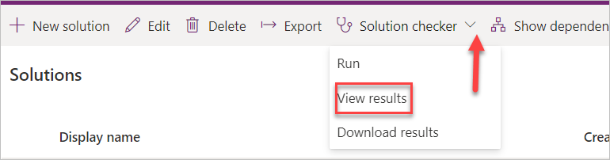
- Review the solution check results and make sure there are no issues.
- Exercise 3: Use test studio
In this exercise, you create use test studio to create test case for submitting a problem report.

Task 1: Create test case
- Navigate to the Power Apps maker portal and make sure you are in the correct environment.
- Select Apps, select the Company 311 Phone application, and click Edit.
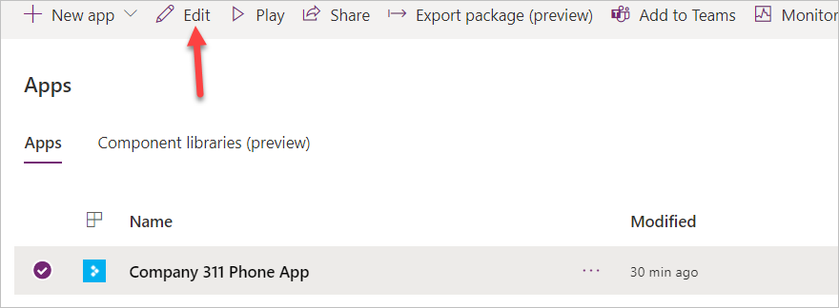
- Click File and select Settings.
- Select Advanced settings.
- Scroll down and enable Formula level error management.
- Click on the back button to go back to the app designer.
Note: Currently test studio cannot record steps inside components like the tab control we are using, you edit the App OnStart formula, so the app navigates directly to the new report screen.
- Select the Tree view tab.
- Select App and add the formula below to the existing formula.
; Navigate('New Report Screen')
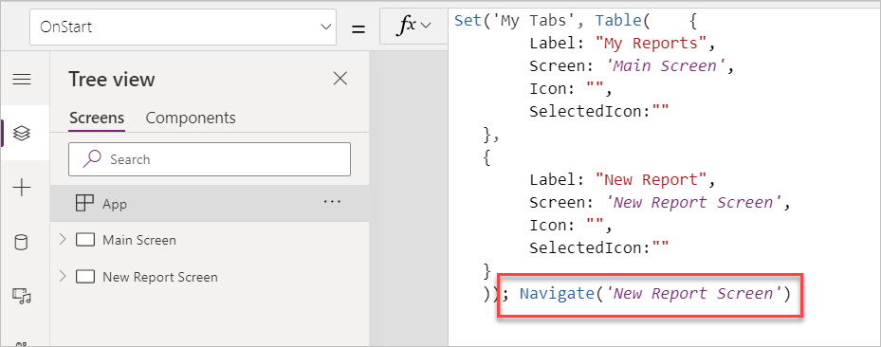
- Click File and select Save.
- Click Publish.
- Select Publish this version and wait for the publishing to complete.
- Click on the back button to go back to the app designer.
- Select the Advanced tools tab and select Open tests.
- Click on the … button of the Case and select Rename.
- Rename the Case to Submit problem report.
- Click Record.
- Select the New Report tab.
- Fill out the form and click Submit.
- Click Done.
- You should see list of the recorded steps.
- Click Play.
- Click Publish and wait for the publishing to complete.
- The steps should replay correctly. Click Done.
- Close the test studio browser window or tab.
- Close the app designer browser window or tab.
- Click Done on the popup.
- Exercise 4: Import export
In this exercise, you will export the company 311 solution and import it into a new environment.

Task 1: Export solution
- Navigate to the Power Apps maker portal and make sure you are in the correct environment.
- Select Solutions, select the Company 311 solution, and click Export.
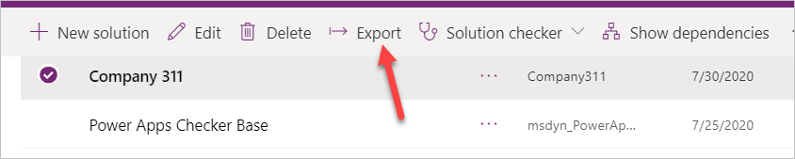
- Click Next.
- Select Managed and click Export.
- Save the solution on your computer.
- Click Export again.
- Click Next.
- Select Unmanaged, change the version to match the managed solution version, and click Export.
- You should have the managed and unmanaged versions of the solution exported.

Task 2: Create new environment and import solution
- Navigate to the Power Apps admin portal
- Select environments and click + New.
- Enter Company 311 Prod for Name, select Trial (not subscription based), select Yes for Create database for this environment, and click Next.
- Select your Language, select your Currency, and click Save.
- Wait for the environment and database to be created, The State will change to Ready when ready. Click on the Refresh button to see the status.
- Select Solutions, select the Company 311 solution, and click Export.
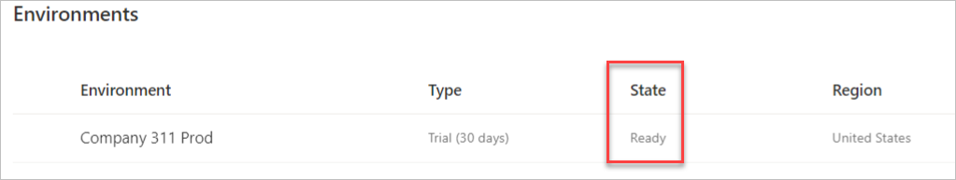
- Navigate to the Power Apps maker portal and select the environment you just created.
- Select Solutions and click Import.
- Click Choose File.
- Select the managed solution you exported and click Open.
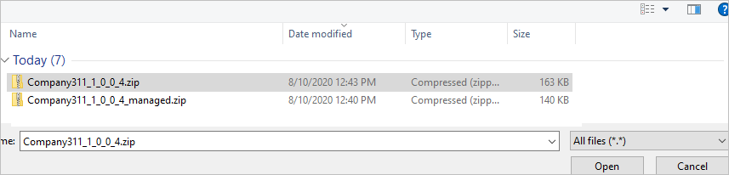
- Click Next.
- Click Next again.
- Click Import and wait for the import to complete.
- Click Publish all customizations and wait for the publishing to complete.
- Click Close to close the import solution wizard.
- Click to open the Company 311 solution you just imported.
- Review the components in solution.
- Select Apps and make sure you have both the Canvas and Model-driven applications.
- Click to open the Company 311 Admin application.
- The application should load without issues.
- Close the Company 311 Admin application browser window or tab.
- Click To open the Company 311 Phone App.
- The application should load without issues.
- Close the Company 311 Phone App browser window or tab.

